1. **Introduction to Microservices**

Monolithic applications are route to microservices

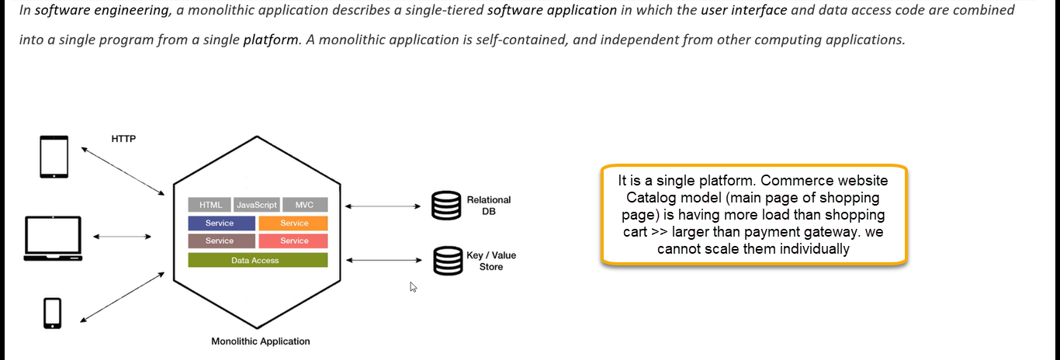

Microservices are more about of forming more number of small containers. Split of application into smaller and interconnected devices

The catlog page ( main page of shopping website) can be used different types of projects can be used for page

Catlog, payment and shopping chart should be separate DB ( EVERY module should be different database)

When integrating the above modules, the testing becomes difficult. If there are different database, then transactions become hard.

**2-Introduction to Kubernetes**

We package our application along with all dependences in one single image. When we want our application running, we will create the instance of our image which we call it as container, and we are up and running from there. Our application which is micro service-based application which has a 50 microservices. For each micro service we will develop one image. Service A is using B, C and D before you launch A, we need to launch B, C and D. node is a computer. Network between nodes we need to create memory allocation we need to do.

Replication of components: every component for the sake of availability we should at least have two instances and if we have lot of loads, we need multiple instances. Auto-Scaling, Load balancer, Rolling Updates- we cannot shutdown our computer because we need to provide an update. Existing request to be taken care of along with upgrading the other instances. If you have five instances running if we need to upgrade the microservice that means all five we need to update. We need to upgrade one at a time. The other four remain alive. Logging across the components at a common place so that at any point of time I will be resolved and reviewed the problems and we need proper monitoring and health check up system. Every service should be discoverable. May we will uniquely name and if that location changes still, it should be discoverable. Also, we need authentication and security of the service

The process of organizing multiple containers and managing them as needed as known as container orchestration.

Admin will create the network of computers and on this network of computers there are going to create a Kubernetes cluster. Each node – each computer will have knowledge of other computers what are services running on them with the help of metadata. The admins are responsible for deploying on a networked computer, certain software’s so that it becomes Kubernetes cluster.

K8s/ubernete. We need to build docker container then only we can use the Kubernetes

If one node/computer is down, then self-healing will be done. One node is down then automatically container will be launched in another node. So that still specified number of nodes will be up and running. With out bringing down the services there will be upgrade happened.

If you have a network and in one of the nodes in the network will instance Kubernetes master. And in other nodes in the cluster, we will have worker/node components. Basically, we need to install the software. If you are using the Azure, then we don’t need to take of Kubernetes master. We need to specify the configuration of working nodes. The cluster is build for you internally.

We need to install the Kubernetes in each physical server or Virtual Machine then only it will form Kubernetes cluster.

Kubernetes master: it is a master node managing a complete cluster and run several core Kubernetes services.

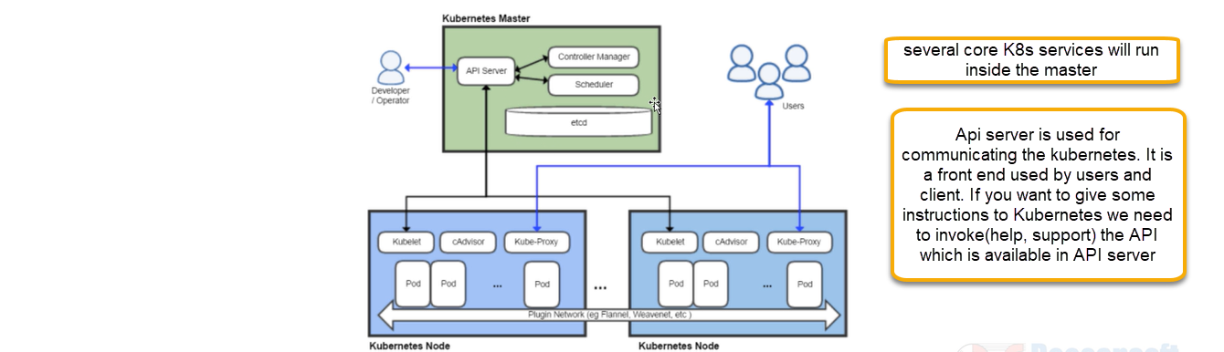

One pod is one container instance. So which container instance should run in which node is all controlled through API server and it is responsible the communication between two components, allocating pods (computer) to available nodes (container instance).

Etcd: high available key value store distributed among the nodes. Connection string can be stored in Etcd and from each of this will be connecting. It stores the information services, pods etc.,

Scheduler: API gives instruction that instruction for deploying the pod will goes to schedule. Scheduler finds the suitable node where pod instance should be created. It is responsible for distributing workload across different nodes in the cluster (where the pods that should be decide by scheduler)

Controller manger: if we opted the 3 instances of my pod if we change to 4 instance control managers will observe that instance has been increased then it will instruct API server and further it will instruct scheduler of one more pod from current state desired state (3 to 4) will be taken care by controller. API is the key all communications will go through API.

Worker node

One pad will have one container. Kubelet, pod all they are getting instructions from API server. API will give instructions >>Kubelet will give instructions to >>pods

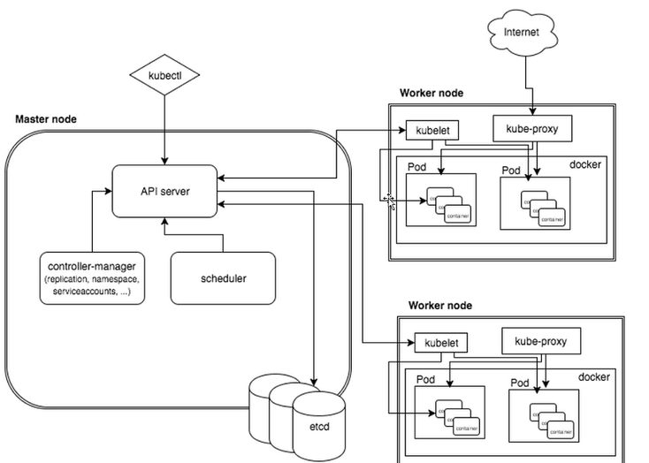

With respect to above diagram inside pod we have a container

Container Run Time: each node will have container runtime Kubelet is main point of contact for master. Kubelet will have a set of podSpecs. We are going to have a YAML file which is desired state how Kubernetes cluster will look/have/supposed to be. From YAML file > api server > Kubelet. Kubelet will use instruction set to take the further action and ensures container should running healthy.

Kubernetes Proxy service will receive request from internet, and it moves appropriate containers. Proxy service will run each node and helps in making the services available to end users. It will divide the load in two different proxies

cAadvisor: all related information about container will take care in cAadvisor

Kubernetes Objects and workloads

Kubectl: it is a CLI command all commands given to Kubernetes cluster using kubectl

Kubectl <operation> <object><resource name><optional flag>

<operation: create, update,>

Kubernetes pods: smallest and simplest unit in Kubernetes model that you create or deploy. A container is a pod and may have one or more containers (such as docker). If you query a pod contains the information about container and metadata

For a given application each pod is meant to run a single instance if you want to scale up applications, we need to use multiple pods for that replication pods will be created, and it will be managed by a Replication Controller

Pods will crush/die and they will not born on their own. In these case replication set will give rebirth to pod(Auto healing). Replication set will be automatically created a new node and in that new node it will move all existing pods. so that node it will be up and running.

Deployments : how to create and update instances. We are going to write a yaml file and in that yaml file is going to give the deployment and that goes to master node. We need to tell through deployment script that we need some instances of pod and it take cares of that aspects of you so many instances will be running even if one machine is down automatically another machine will be created. Deployment controller is a key of rebirth with the help of replication sets. If you create a pod without controller then there is no concept of rebirth of pod.

Service Our request will go proxy > proxy will go to the service and service will send to pod it is responsible for allowing the traffic

1. Creating ACR and AKS Services along with Service Principal Permissions

How to create a Kubernetes cluster and deploy application in Kubernetes cluster

Package your application in one or more containers > push those images into Azure container registry (ACR) for more details see below image

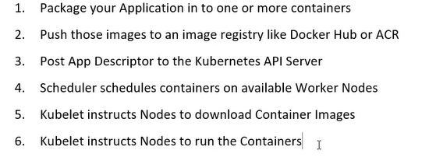

Develop and Test the application locally

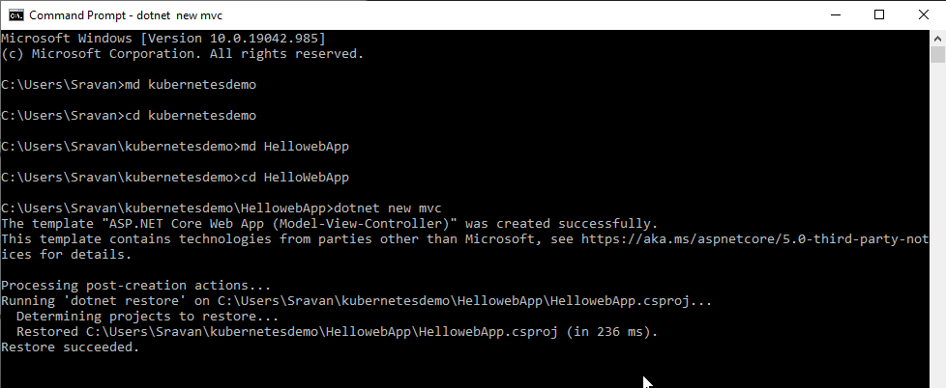

we have created a mvc project in that mvc project we need a docker file

type code . in cmd

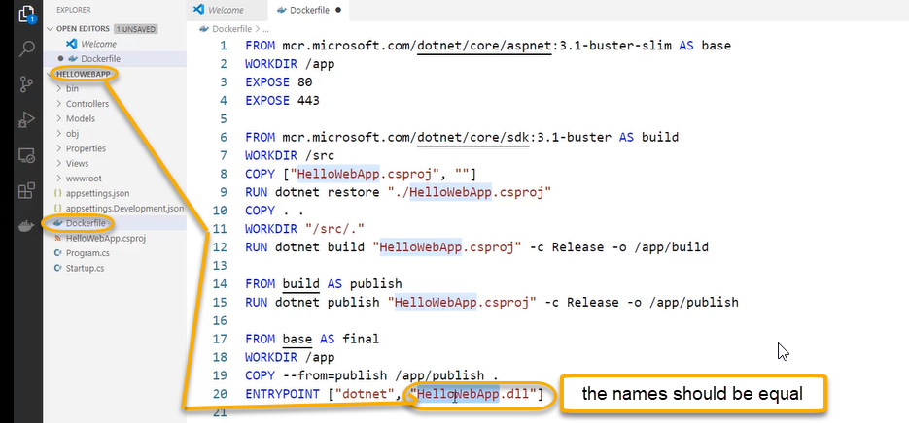

Now we need to build a docker image

docker build -t sravan/hellowebapp .

HelloWebApp>docker build -t sandeepson (image name)/hellowebapp .(. dot which is the context)

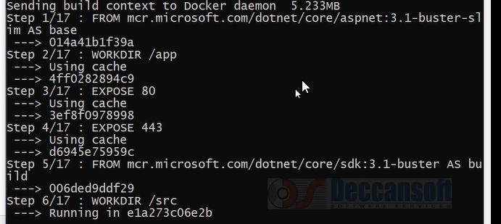

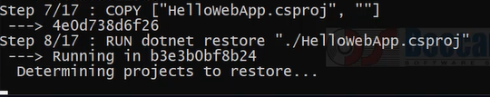

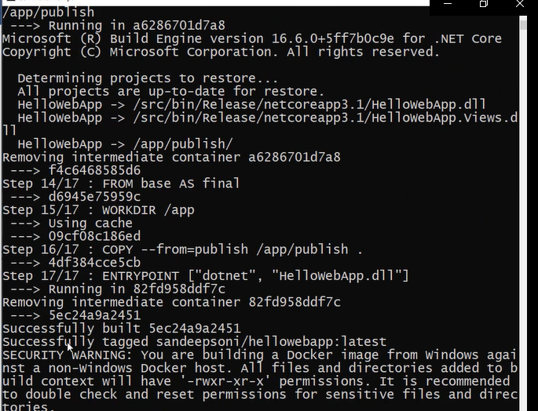

If you need to test locally

HelloWebApp>docker run -p "8080:80" sandeepsoni (image name)/hellowebapp

P (port mapping)

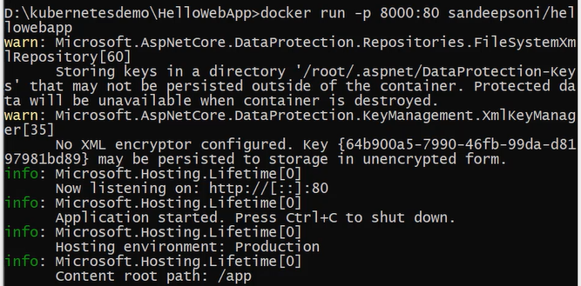

If you browse it in web browser

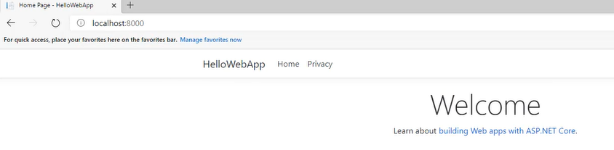

Kubernetes is not interested what is there in the application. We need to put an image in Azure container registry. We need to create a Azure container registry

Portal.azure.com > create a container registry

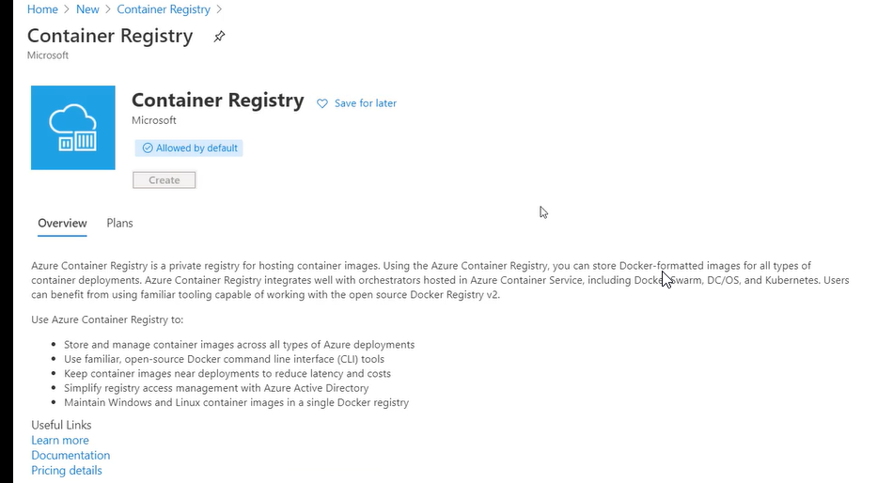

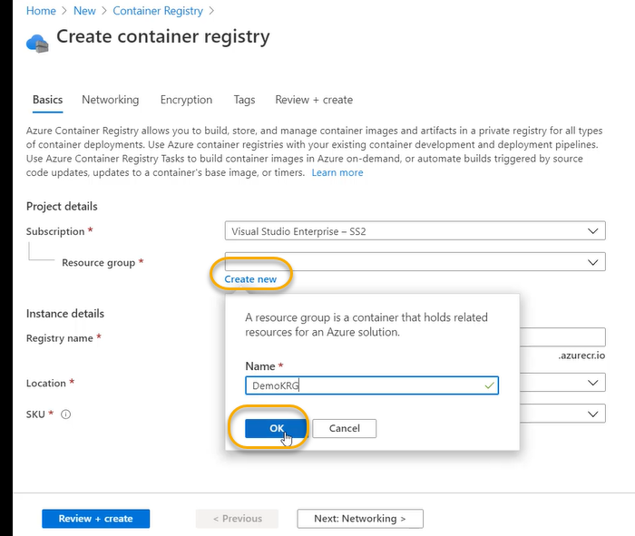

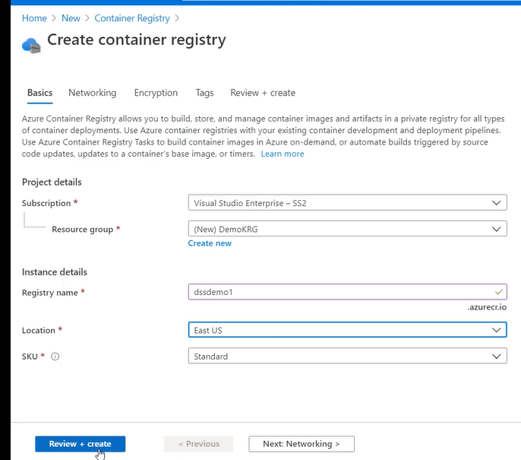

Rest all keep it as it as and create

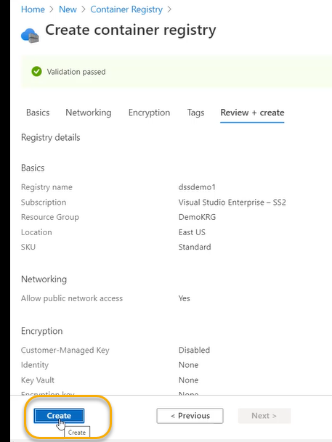

Click on Ctrl+C to terminate the present session

We need to put an image in container registry for that we need to do tagging. right now our image name is sandeepsoni/hellowebapp however this image name we cannot push into azure container registry. We need to use the name “dssdemo1.azurecr.io/helloworldapp”

For that we need to do first tagging docker image tag sandeepsoni/helloworld app dssdemo1.azurecr.io/helloworld (repository) we can give additional tag name like: v1,: v2, : latest

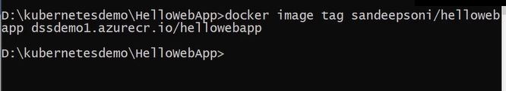

Login to ACR: docker login --username dssdemo1 --password dssdemo1.azurecr.io

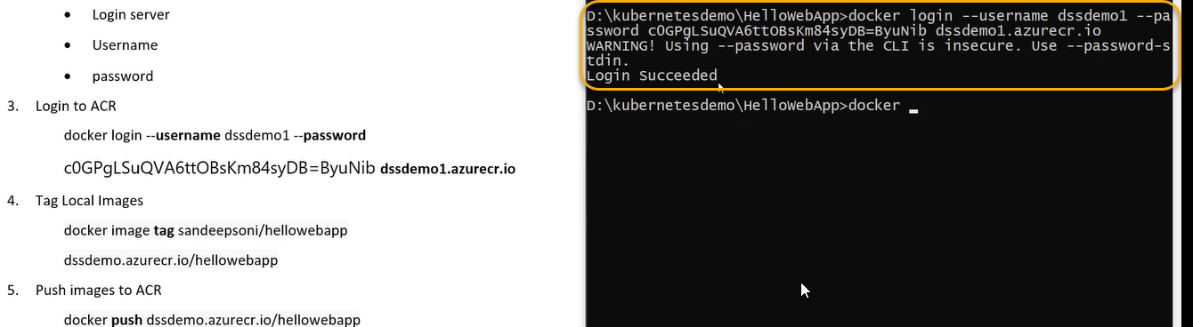

Now we need to push

docker push dssdemo1.azurecr.io/hellowebapp

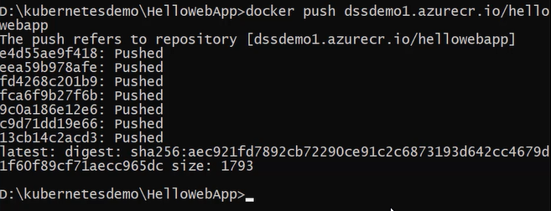

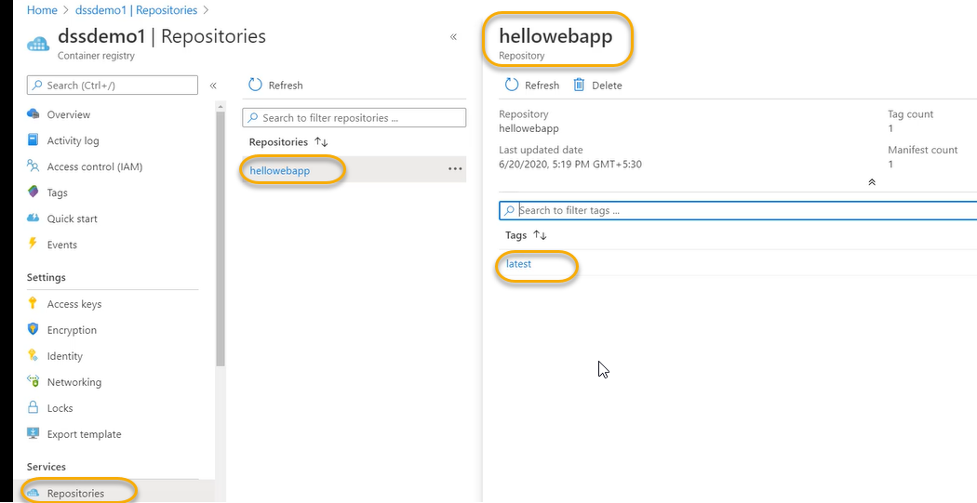

Now we need to create the Azure Kubernetes cluster

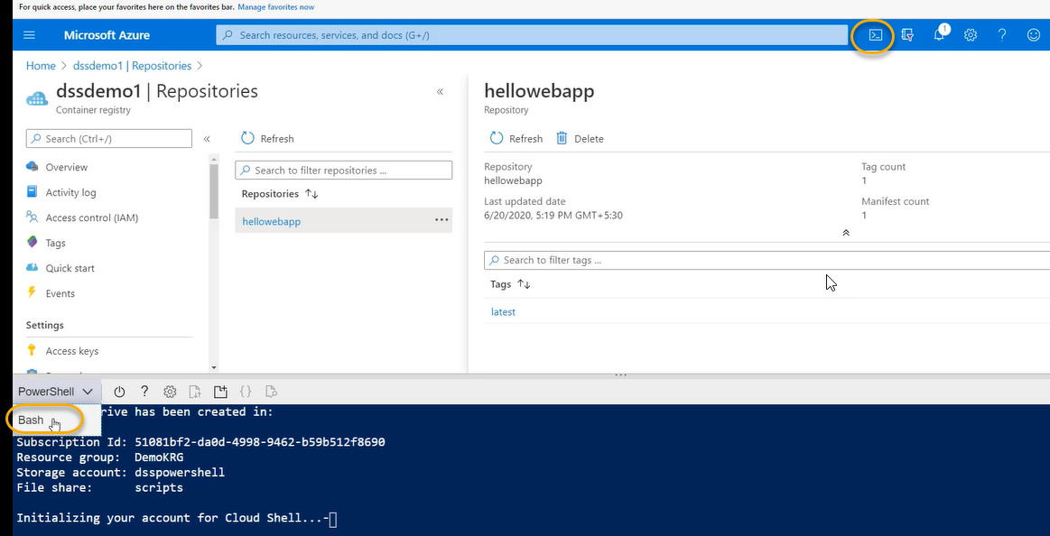

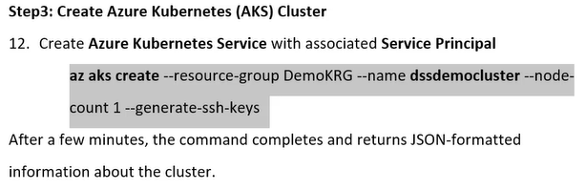

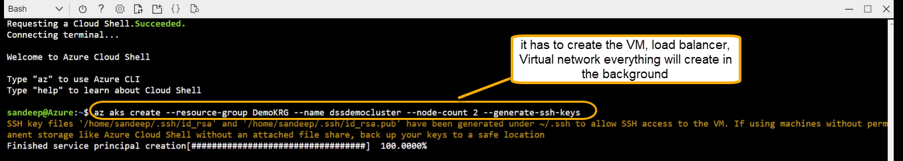

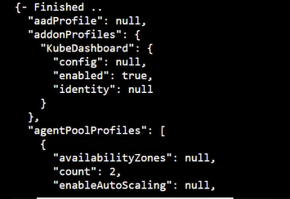

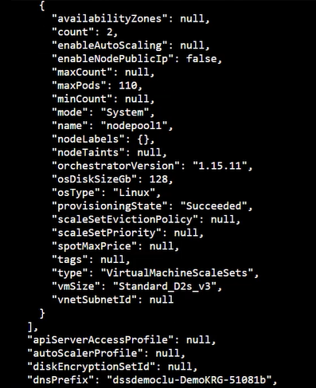

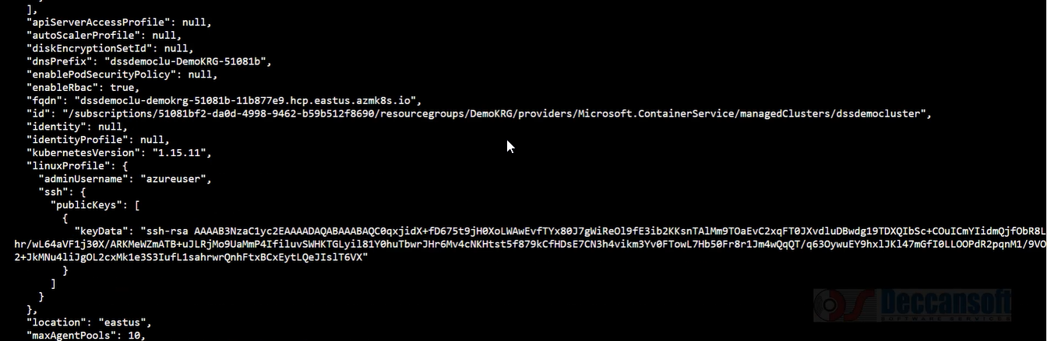

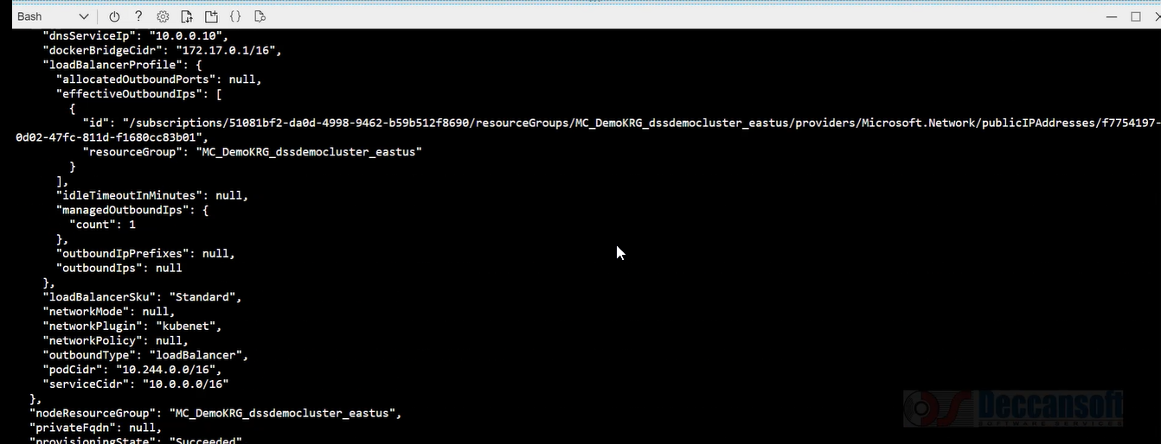

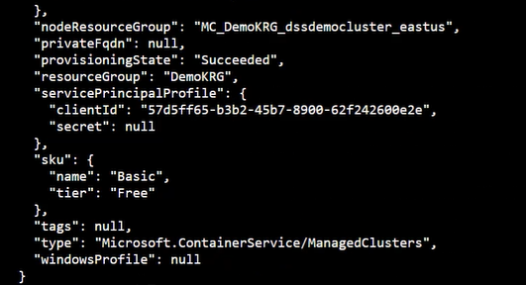

Between Kubernetes cluster and azure container registry we must establish the trust so that Kubernetes cluster will download the image from the registry.

Kubernetes must be access to ACR. When Kubernetes cluster is created there is service principal has been created (which we see in the above screenshot). That service principal we need to have give permission

acrpull role assignment we need to give in the azure Kubernetes cluster and thus aks cluster will able to pull the image from azure container registry which is secure

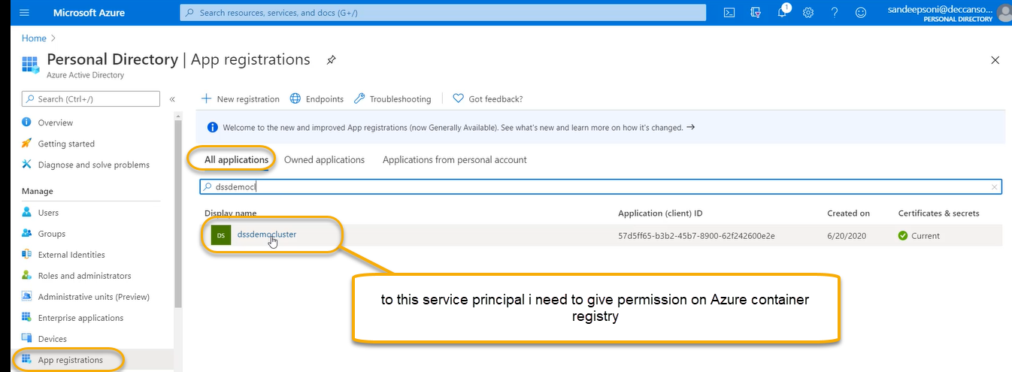

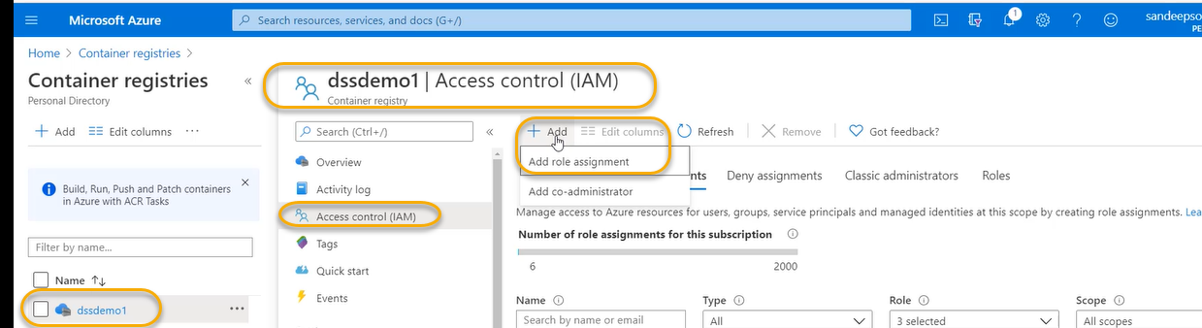

We need to give permission acrpull to cluster

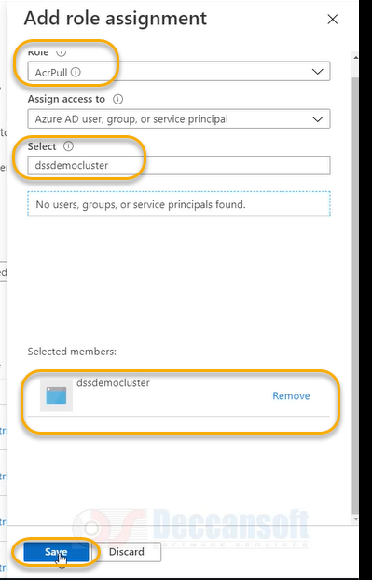

So that cluster will be able to pull the images from azure container registry

To know the current status of the cluster

On your local machine we need to execute az login

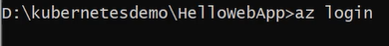

It will open the browser

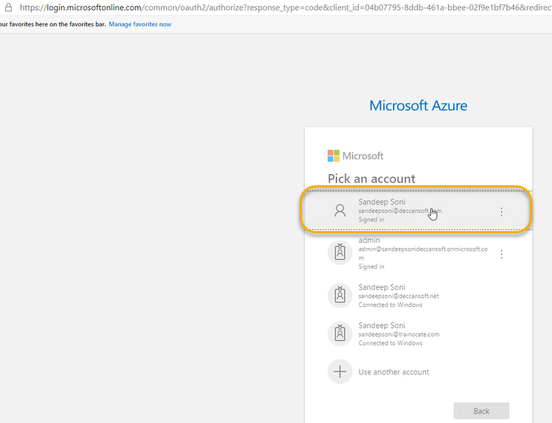

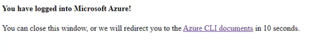

And also in parallel we see in the cmd the available subscriptions will be displayed as we have logged into aure



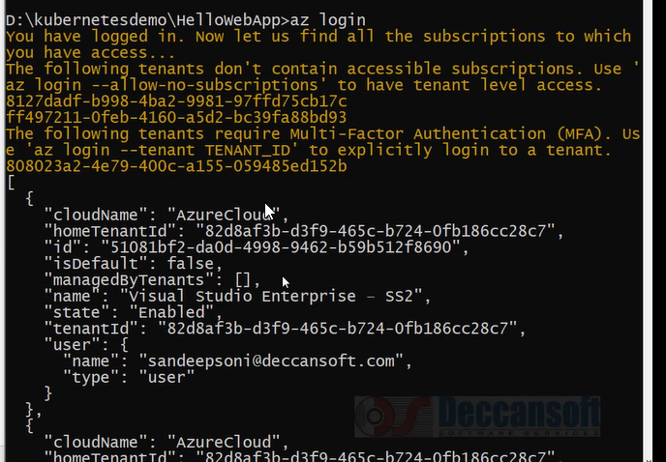

While setting the az account set if we have issues name use the ID as we see in the below

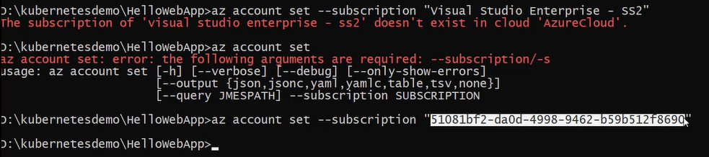

Or we can execute the below things

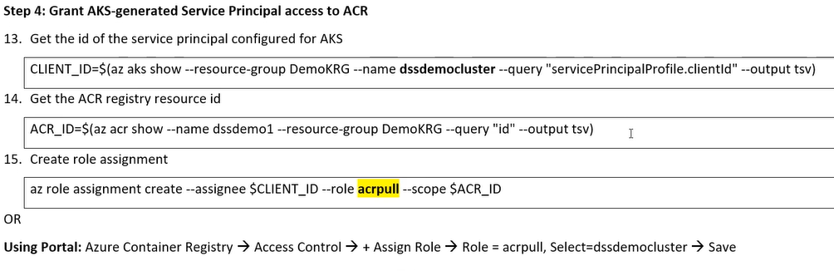

4-Hosting Application in Kubernetes Cluster



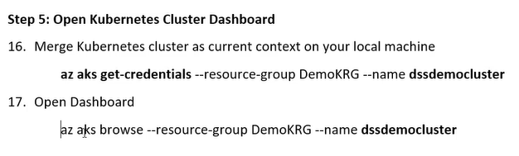

In the above screenshot we see the c drive and in that c drive token has been successfully generated

To know the status of cluster



If you enter it after executing the command it will open the browser

It will automatically opens the dashboard but dashboard does not have permission to work with aks cluster

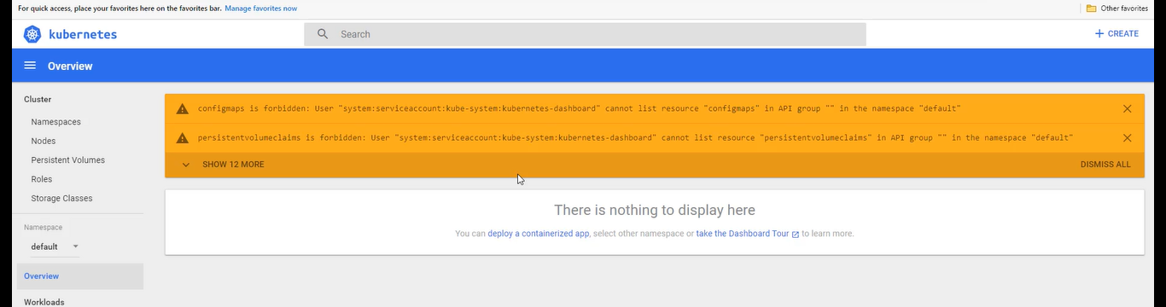

We need to create a role binding -n=name space

Before that we need to install kubectl on our local machine

To manage the Kubernetes cluster, we need to use the kubectl command line client

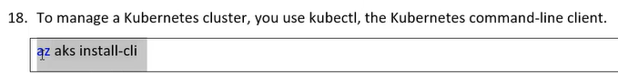

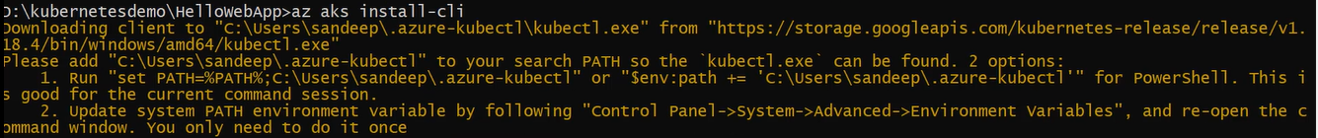



Now the dashboard should access to cluster execute the below command ( to access the dashboard)



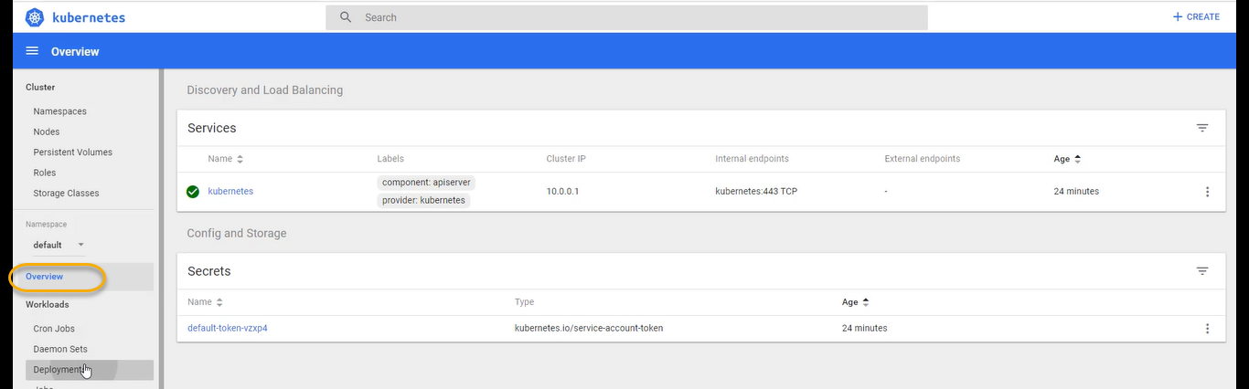

If it is not working, we can execute the below highlighted ones ( point 20, 21, 22, 23)

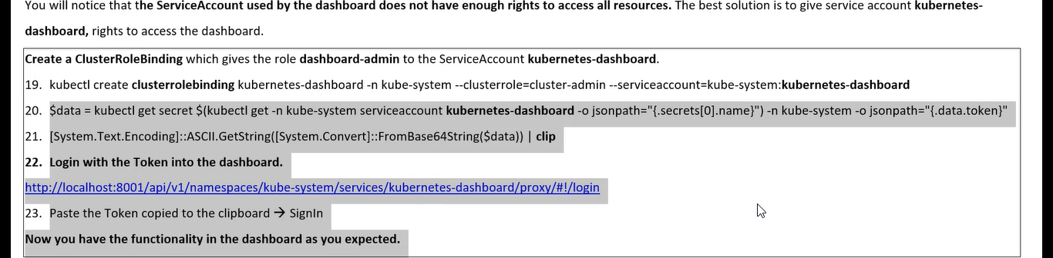

Now we need to deploy into the Kubernetes cluster

Kubernetes require yaml file for deployment

We can put all Kubernetes components in a single yaml file or we can put deployment and service as separate.

Now stop the job and code .

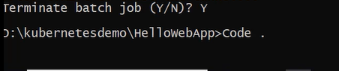

We need to create the manifest file and under manifest file we need to create the yaml file

If you are combing two files then we need to use the separator between deployment and service as shown below

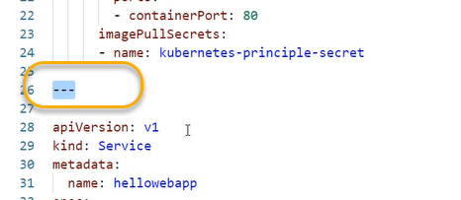

Deployment.yaml

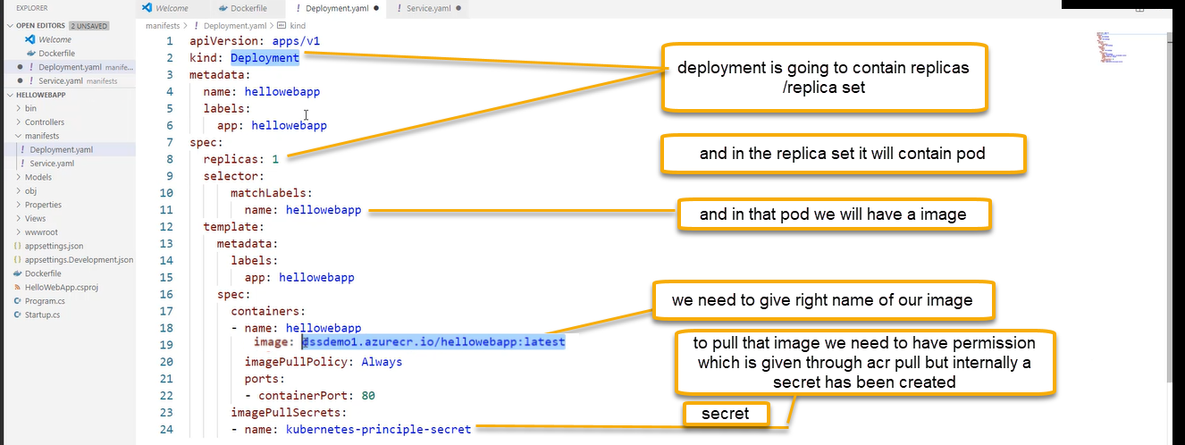

In the above screenshot at line 11 use the app: hellowebapp instead of name: hellowebapp

Service principal is accessible to azure container registry, but Kubernetes has to use through deployment through secret. Kubernetes cluster will use the secret which we will identity of azure AD principle and using that identity it will access Azure container registry and fetch this image

The secret is going to contain the information about connecting to service principle and yaml use this secret to download the image from ACR

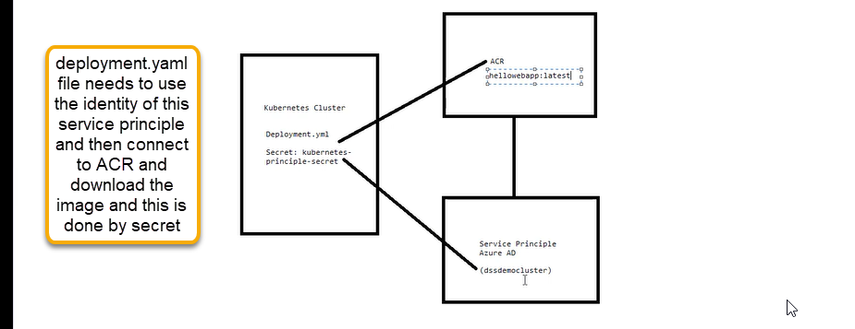

How to achieve the secret we need to run the below command

This secret can be used in deployment.yaml script

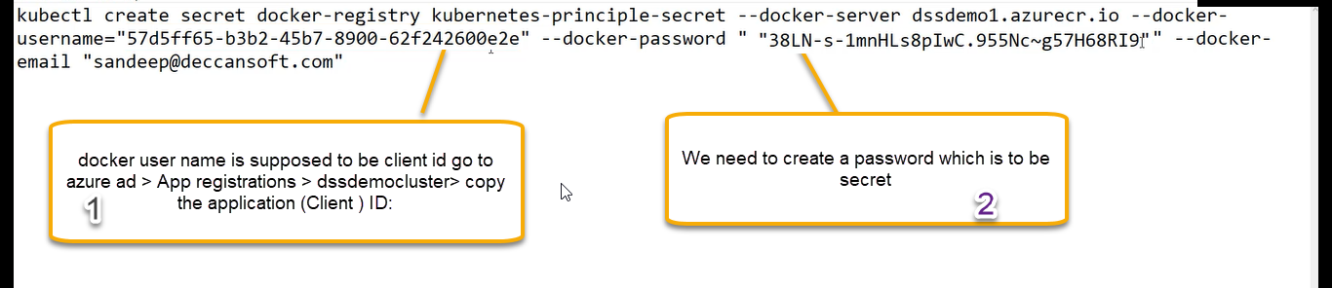

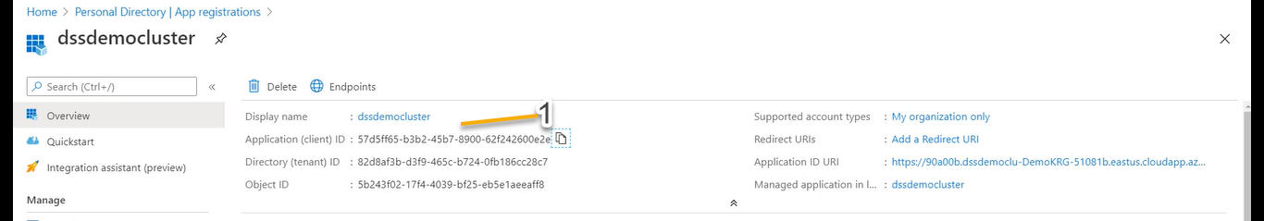

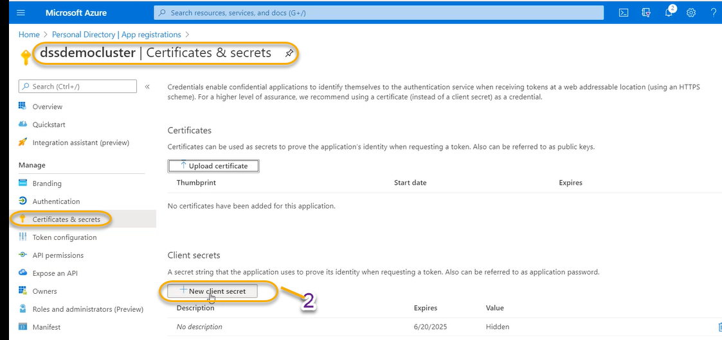

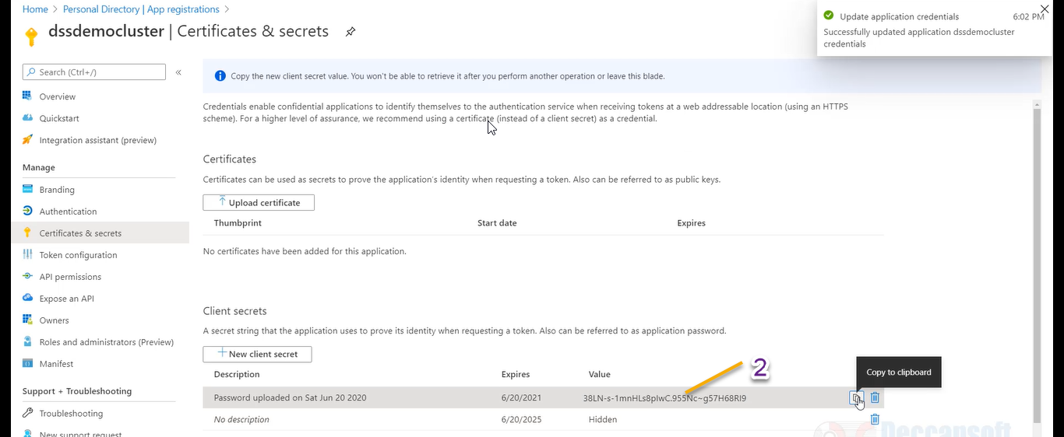





Now access the dashboard



It will navigate to Kubernetes

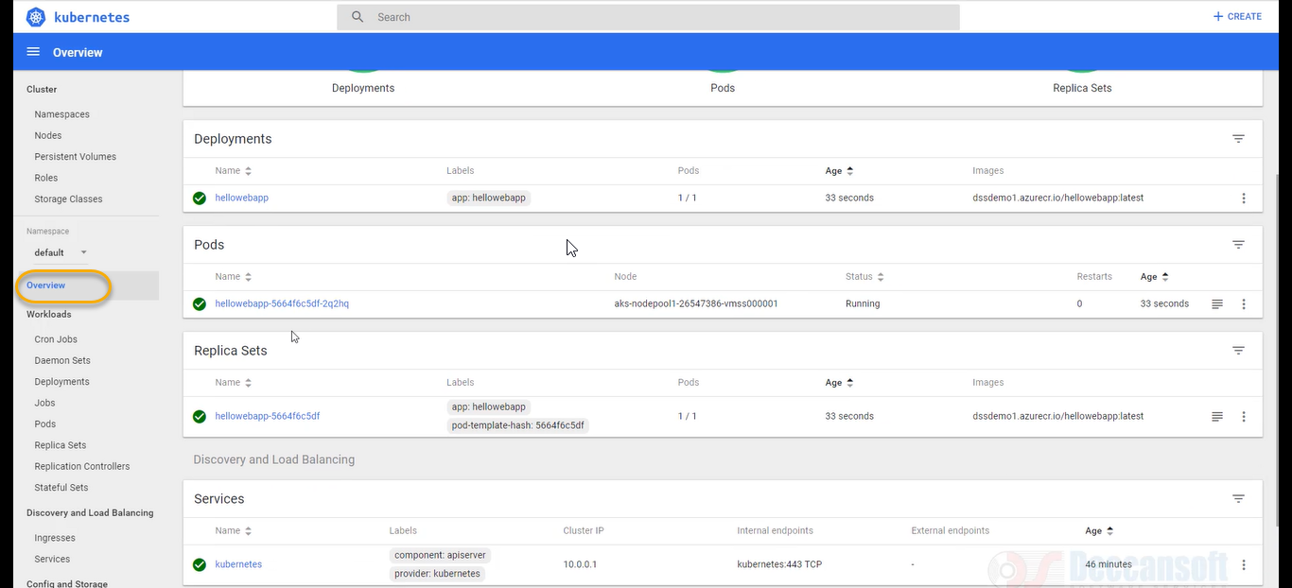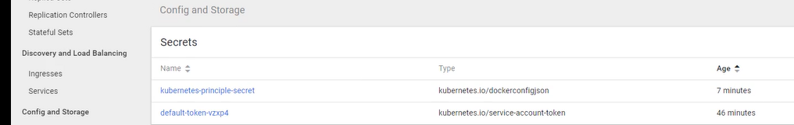

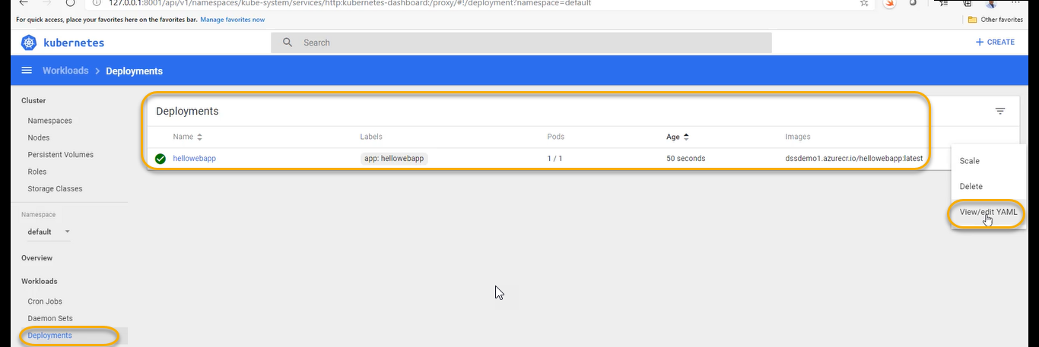

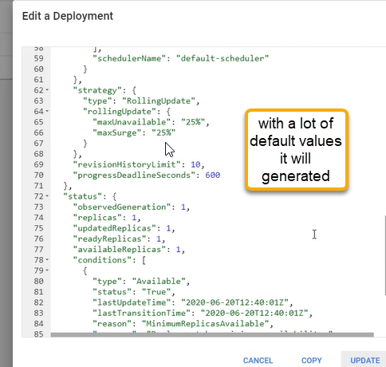

If you change the replica values as “2” and update

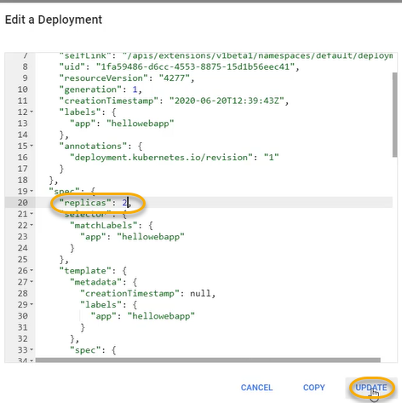

And we notice that deployment will start again

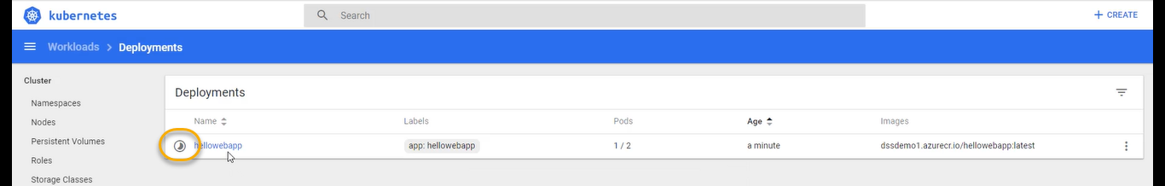

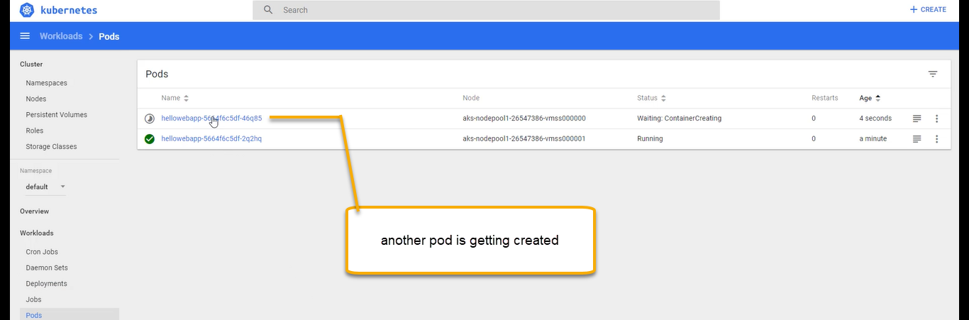

Complete cluster is controlled by yaml ( declarative yaml)

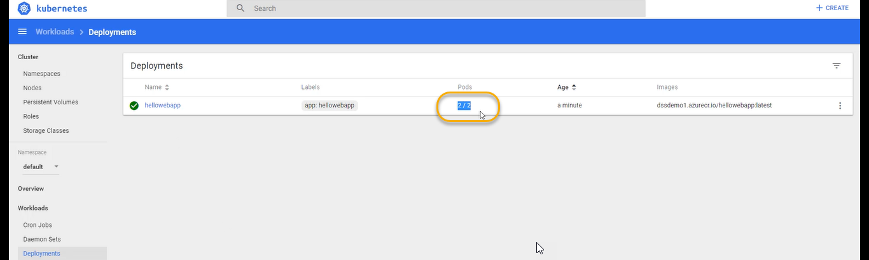

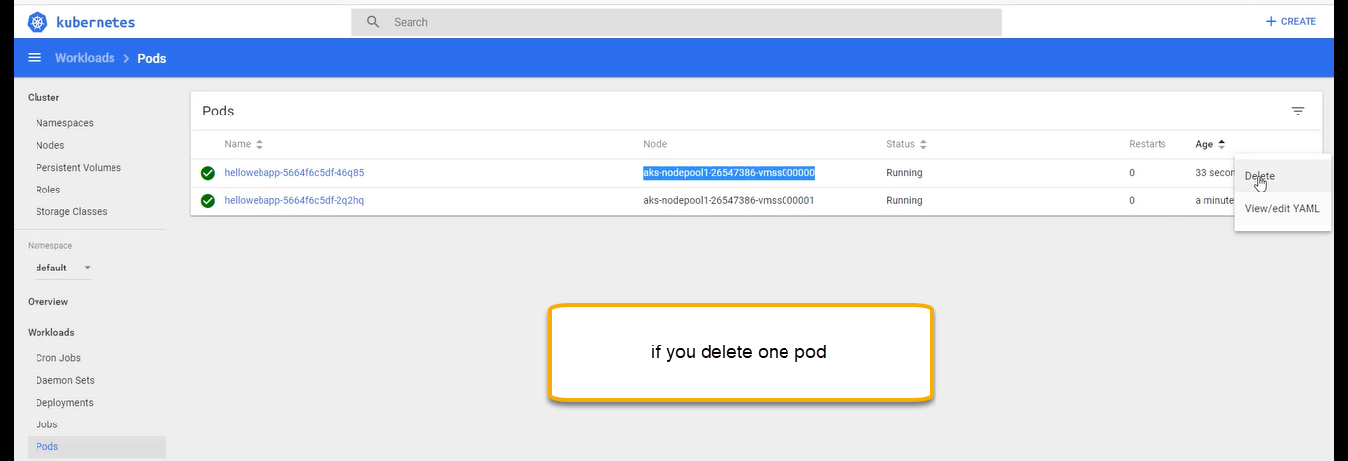

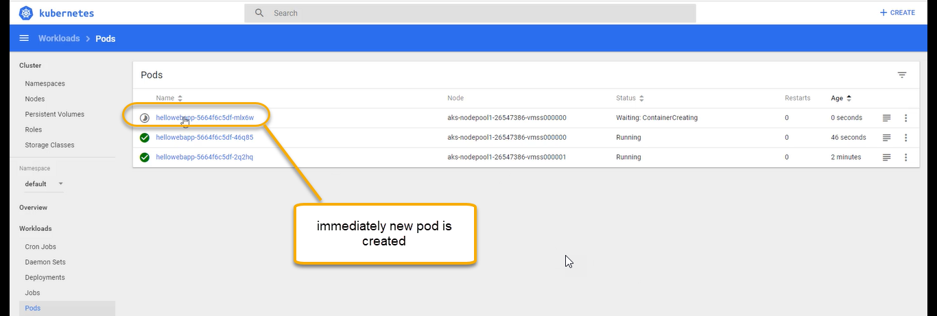

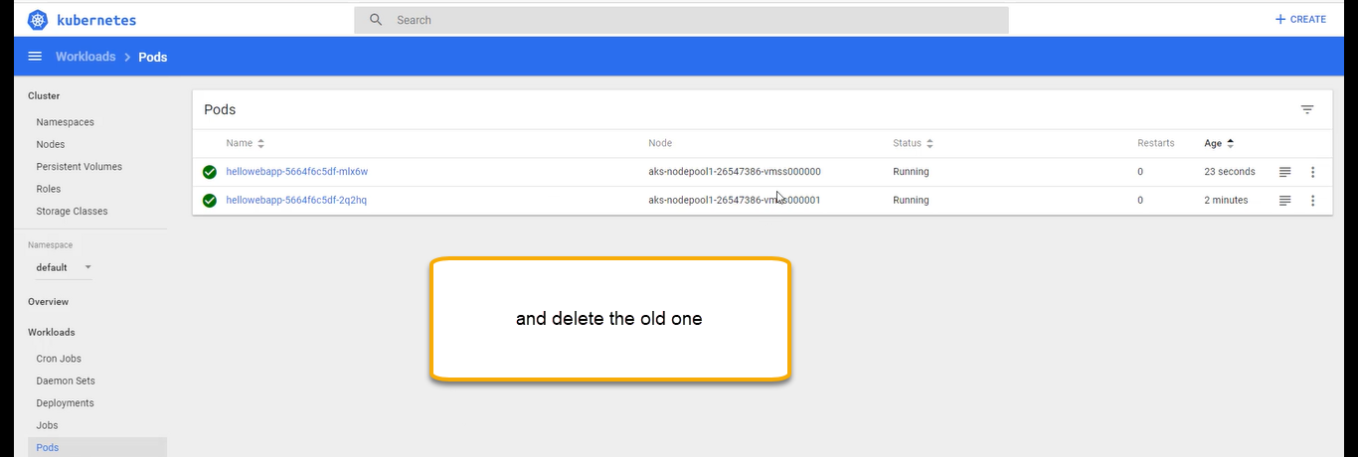

Ideally used for hosting micro-based applications. As of now deployment has been done for one micro service in real time, we will have 10 microservices.

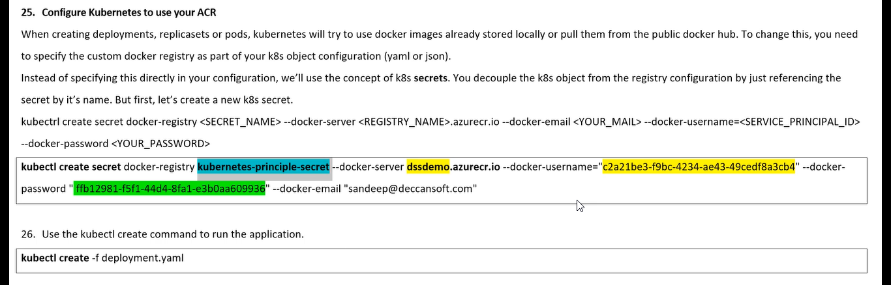

Now we need service without service we will not invoke the application. Service is the only way Kubernetes cluster provide the access to the pods which are inside it.

Service.yaml

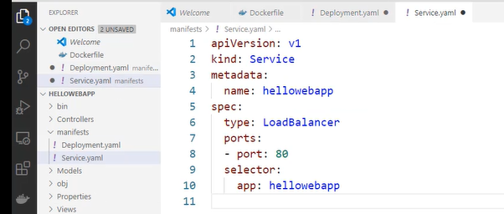

Execute the below command in cmd



Now we see in Kubernetes service has been created

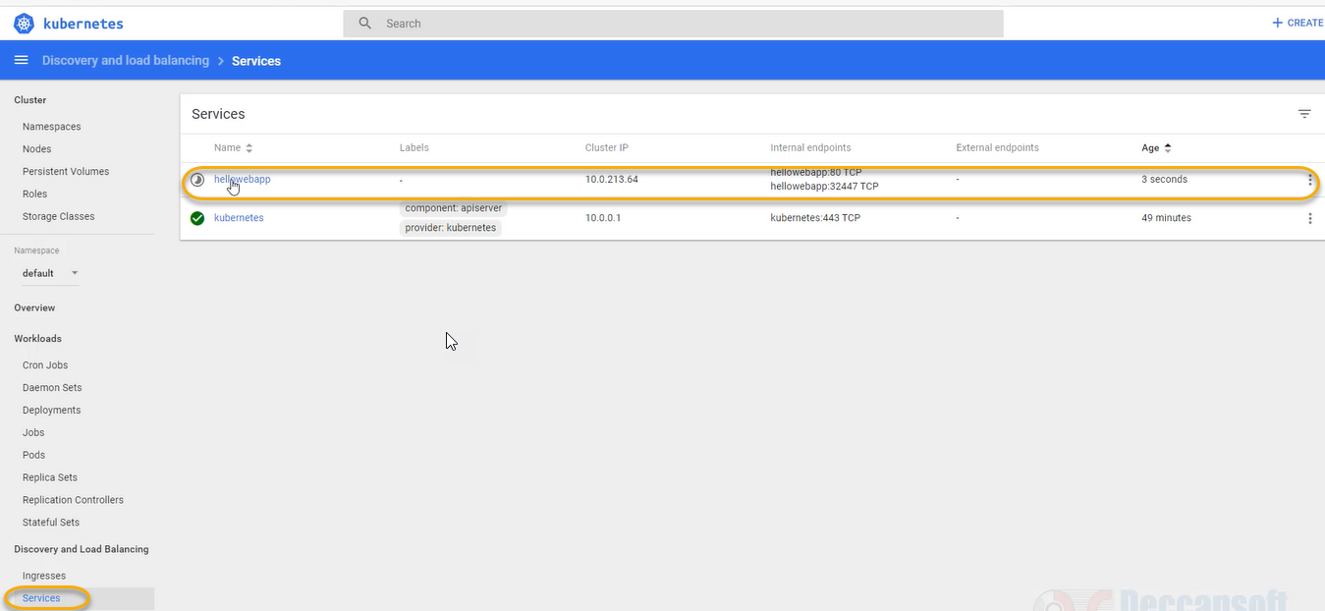

Once the service is created, we see the external end points which is the Ip address please see the below one

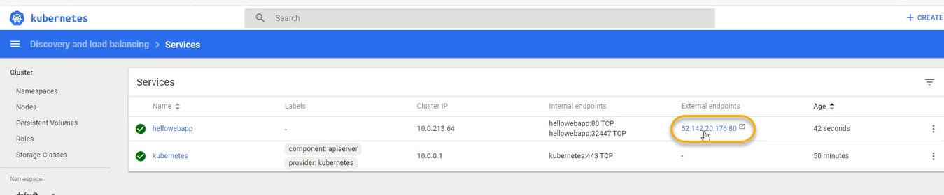

By clicking on the above link we see the web app as we see in the below

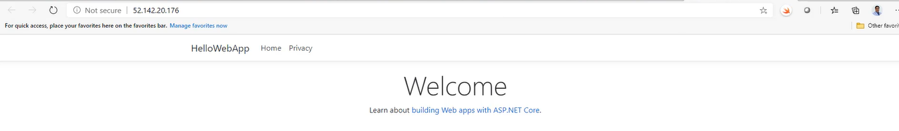

If the load is more re execute the deployment file by increasing the count of replicas

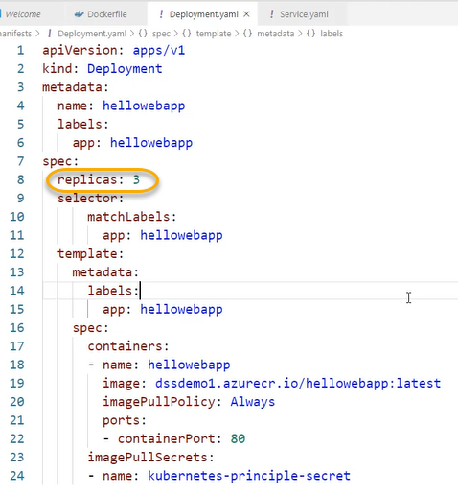

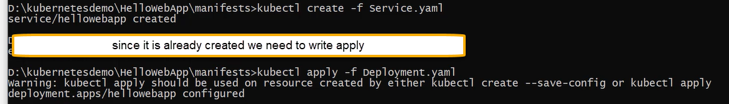

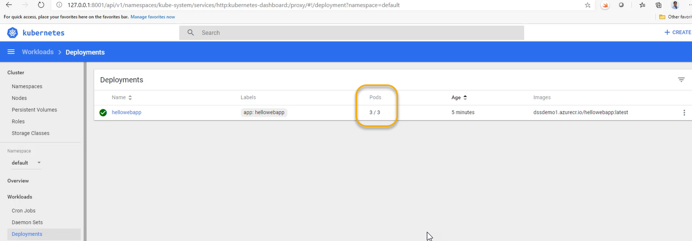

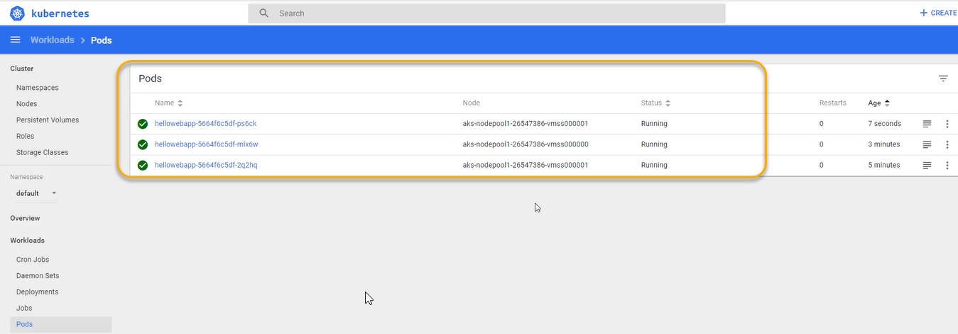

We can view this info in cmd

